# Lab 09:

1. Write a program using one-dimensional array of numbers and finds the average of a set of numbers.

## **Code**:

**package** lab9;

**public** **class** arrayex {

**public** **static** **void** main(String[] args) {

**double**[] arr = {19, 12.89, 16.5, 200, 13.7};

**double** total = 0;

**for**(**int** i=0; i<arr.length; i++){

total = total + arr[i];

}

**double** average = total / arr.length;

System.***out***.format("The average is: %.3f", average);

}

}

## **Output**:

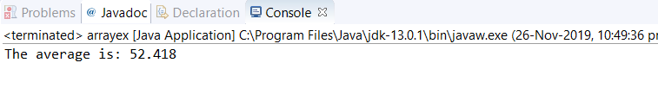

2. Write a program to initialize the elements of 2D array with random numbers.

## **Code**:

**package** lab9;

**public** **class** task2 {

**public** **static** **void** main(String[] args) {

**int**[][] table= **new** **int** [4][3];

**int** r = (**int**)(Math.*random*()*(9-1+1))+1;

**for**(**int** row = 0; row < table.length; row++){

**for**(**int** column = 0; column < table[row].length; column++){

table[row][column]=r;

System.***out***.println(table[row][column]);

}

}

}

}

## **Output**:

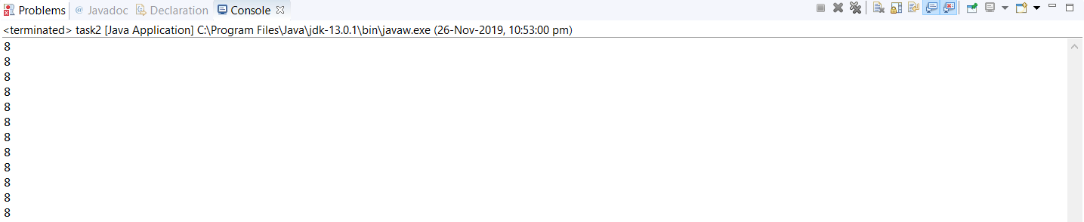

3. Write a program to explore different methods of String class.

## **Code**:

**package** lab9;

**public** **class** test {

**public** **static** **void** main(String[] args) {

{

String s= "GeeksforGeeks";

System.***out***.println("String length = " + s.length());

System.***out***.println("Character at 3rd position = " + s.charAt(3));

System.***out***.println("Substring " + s.substring(3));

System.***out***.println("Substring = " + s.substring(2,5));

String s1 = "Geeks";

String s2 = "forGeeks";

System.***out***.println("Concatenated string = " + s1.concat(s2));

String s4 = "Learn Share Learn";

System.***out***.println("Index of Share " + s4.indexOf("Share"));

System.***out***.println("Index of a = " + s4.indexOf('a',3));

Boolean out = "Geeks".equals("geeks");

System.***out***.println("Checking Equality " + out);

out = "Geeks".equals("Geeks");

System.***out***.println("Checking Equality " + out);

out = "Geeks".equalsIgnoreCase("gEeks ");

System.***out***.println("Checking Equality " + out);

**int** out1 = s1.compareTo(s2);

System.***out***.println("If s1 = s2 " + out);

String word1 = "GeeKyMe";

System.***out***.println("Changing to lower Case " +word1.toLowerCase());

String word2 = "GeekyME";

System.***out***.println("Changing to UPPER Case " + word1.toUpperCase());

String word4 = " Learn Share Learn ";

System.***out***.println("Trim the word " + word4.trim());

String str1 = "feeksforfeeks";

System.***out***.println("Original String " + str1);

String str2 = "feeksforfeeks".replace('f' ,'g') ;

System.***out***.println("Replaced f with g -> " + str2);

}

## }

}

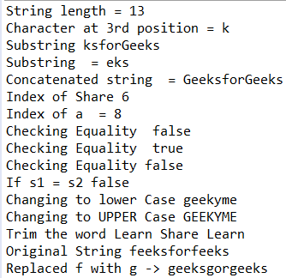

1. Write a Java program that checks whether a given string is a palindrome or not. Ex: MADAM is a palindrome?

# **Code**:

**package** lab9;

**import** java.util.Scanner;

**public** **class** lab9as {

**public** **static** **void** main(String[] args) {

String str, rev = "";

Scanner sc = **new** Scanner(System.***in***);

System.***out***.println("Enter a string:");

str = sc.nextLine();

**int** length = str.length();

**for** ( **int** i = length - 1; i >= 0; i-- )

rev = rev + str.charAt(i);

**if** (str.equals(rev))

System.***out***.println(str+" is a palindrome");

**else**

System.***out***.println(str+" is not a palindrome");

}

}

## **Output**:

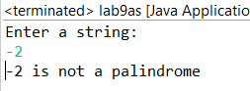

2. Write a Java program for sorting a given array of numbers in ascending order?

# **Code**:

**package** lab9;

**import** java.util.Scanner;

**public** **class** lab9as2 {

**public** **static** **void** main(String[] args) {

**int** n, temp;

Scanner s = **new** Scanner(System.***in***);

System.***out***.print("Enter no. of elements you want in array:");

n = s.nextInt();

**int** a[] = **new** **int**[n];

System.***out***.println("Enter all the elements:");

**for** (**int** i = 0; i < n; i++)

{

a[i] = s.nextInt();

}

**for** (**int** i = 0; i < n; i++)

{

**for** (**int** j = i + 1; j < n; j++)

{

**if** (a[i] > a[j])

{

temp = a[i];

a[i] = a[j];

a[j] = temp;

}

}

}

System.***out***.print("Ascending Order:");

**for** (**int** i = 0; i < n - 1; i++)

{

System.***out***.print(a[i] + ",");

}

System.***out***.print(a[n - 1]);

}

}

## Output:

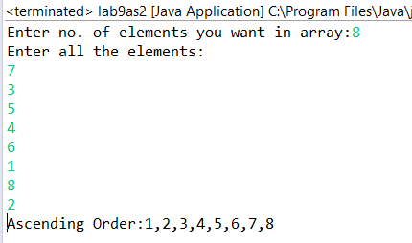

3. Write a Java program to multiply two given matrices using 2D array.

## **Code**:

**package** lab9;

**public** **class** lab9as3 {

**public** **static** **void** main(String[] args) {

**int** r1 = 2, c1 = 3;

**int** r2 = 3, c2 = 2;

**int**[][] firstMatrix = { {3, -2, 5}, {3, 0, 4} };

**int**[][] secondMatrix = { {2, 3}, {-9, 0}, {0, 4} };

**int**[][] product = **new** **int**[r1][c2];

**for**(**int** i = 0; i < r1; i++) {

**for** (**int** j = 0; j < c2; j++) {

**for** (**int** k = 0; k < c1; k++) {

product[i][j] += firstMatrix[i][k] * secondMatrix[k][j];

}

}

}

**for**(**int**[] row : product) {

**for** (**int** column : row) {

System.***out***.print(column + " ");

}

System.***out***.println();

}

}

}

## **Output**:

